

**CST120 Test 1**

**I have neither given nor received help on this exam: ”Chris Thomas”**

**Test will not be accepted without signature.**

1. ( 5 Pts) What is a Cross Compiler?
   1. Basically, you can write code on one machine that is then uploaded and run on another machine. Example being writing C code on computers and then uploading it to the Arduino.
2. ( 5 Pts) What is Masking?
   1. Comparing two binary values to either set or unset bits. Using an AND or OR to either set or unset specific digits in the binary number.
3. ( 15 Pts) Assume we have three variables a, b, and c. If a holds 0x0F and b holds 0xAA. What would be the result of the following operations?
   1. c = a & b; 0000 1010
   2. c = a | b; 1010 1111
   3. c = a ^ b; 1010 0101

* 1. c = ~a; 0101 0101

* 1. c = a >> 2; 1010 1000

1. ( 5 Pts) What does the DDRB register do?
   1. Sets the pin of PORTB to either input or output. It is the DataDirectionRegister for PORTB. A 1 configures it for output and a 0 configures it for input.
2. ( 5 Pts) What does the PORTB register do?
   1. PORTB controls the actual ports on the board. If set to input giving it a 1 will enable the pull-up resistor and a 0 will disable it. If set to output a 1 will send a logic high out and a 0 will send out a logic low.
3. ( 5 Pts) What does the PINB register do?
   1. Toggles the logic level of PORTB.
4. ( 10 Pts) Fill in the “blanks” in the code below to continuously blink the LED mounted on the UNO board. Using Timer/Counter 1 turn the LED on for 1/4 second and then turn it off for 1/4 second. Use a PreScaler value of 64 and mode 0.

/* Using timer/counter1 in mode0 - normal mode

demonstrates polling*/

#include <avr/io.h>

int main(void)

{

// Set PORTB pin connected to LED mounted on UNO As Output

DDRB |= (1 <<DDB5);

/* Turn On LED */

PORTB=0x20;

// Set Up Timer at Prescale Value of 64, mode 0

TCCR1B |= (1 << CS10 | (1 << CS11);

//set timer/counter1 to zero

TCNT1=0;

while (1)

{

if(TCNT1 >= 62500)

{

//Toggle The LED

PORTB ^= (1 << DDB5);

// Reset The Counter

TCNT1 = 0;

}

}

}

1. (5pts) What does a Digital to Analog Converter (DAC) do?
   1. It takes a digital signal and converts it into something that can be used to control something analog. Like dividing the voltage to control the amount of liquid being added to a system.
2. (10 pts) In Lab 2 we used the following equation to determine what the output voltage should have been for a 4 bit DAC given a binary input. Recall, a binary 0 was represented by 0V and a binary 1 was represented by 5V:

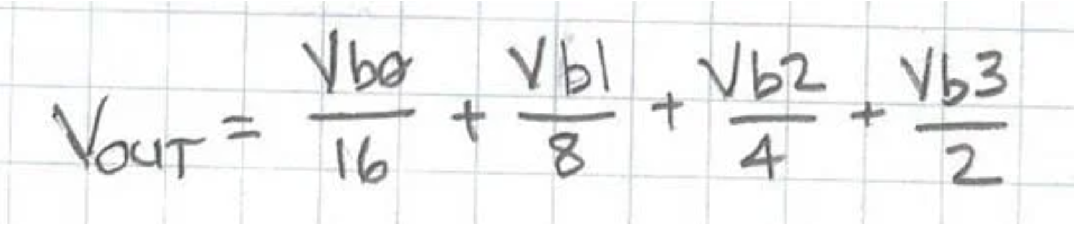

Vb0 = bit 0 voltage, Vb1 = bit 1 voltage, Vb2 = bit 2 voltage, Vb3 = bit 3 voltage

We will assume that we have an 8 bit DAC. The input to the DAC will be bits 0 through 7. The equation needed to calculate Vout is:

Vout = (Vb0/256)+(Vb1/128)+(Vb2/64)+(Vb3/32)+(Vb4/16)+(Vb5/8)+(Vb6/4)+(Vb7/2)

In the 8 bit equation above Vb0 = 0V when bit0 =0 and it equals 5V when bit0 =1. The other bits follow that same pattern (Said another way -> Vbn = 0V if bit n =0 and Vbn = 5V if bit n = 1).

Determine the binary number into the DAC that will produce an Output Analog Voltage of 2.75 V.

Vb0 – Vb7

Output Voltage = 1011 0001

1. (20 pts) In Lab 3 we built a countdown timer. The countdown started when we pressed a button. It started the countdown at 9 and counted to 0 with a time interval of one second between counts. When the count equaled 0 the active buzzer buzzed for 1 second.

For Problem 10 we will build a count-up timer. The timer will start counting at 0 after a pushbutton press and will count up to hexadecimal F (decimal 15). When 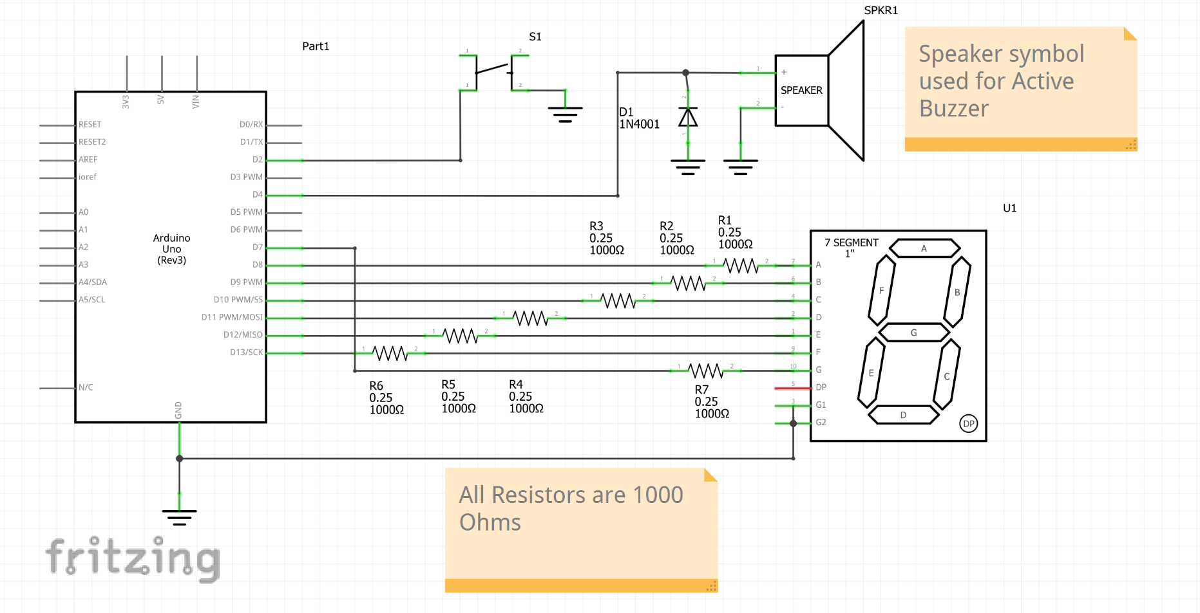the count equals F the active buzzer will buzz for one second. Please note from the schematic on the next page that the pushbutton switch is connected to pin 2 of PortD while the active buzzer is connected to pin 4 of PortD. The pushbutton and buzzer are therefore connected to different PortD pins then they were in Lab 3. Display the count greater than 9 as hexadecimal digits. Also, for count 11 use a small case B (“b”) and for count 13 use a small case D (“d”).

For this problem you must build the circuit, write the code and run the code with the circuit. Turn in your main.c file with your test. I will check your code by running it on my hardware.

1. (15 pts) Using Timer1 with a Prescale Factor of 256 write a program that will blink the LED on the UNO Board (connected to PortB Pin 5) on for 1 second and then off for one second. Don’t use a “delay” statement. Comment you code. Make sure that your code will build, download to your UNO, and execute properly in the UNO. Turn in your main.c code with your test.